PAYD

PC001

Program Specifications (Client Server Environment)

**Record of Release**

|  |  |  |  |  |  |
| --- | --- | --- | --- | --- | --- |
| Version No. | Modified By | Reviewed By | Authorized By | Release Date | Modifications Done |
| <Ver.> | <Full Name> | <Full Name> | <Full Name> | <Release Date> |  |
| 0.1 | Khushi Sidana, Shaurya Verma | Khushi Sidana | Mann Patel | 12/09/2020 |  |
|  |  |  |  |  |  |
|  |  |  |  |  |  |
|  |  |  |  |  |  |

Table of Contents

1. Introduction 3
   1. Objective: 3
   2. References 3
2. Database Design 3
   1. Owned by Module 3
3. Screen Design 4
   1. The Premium Calculation Module (PRM_CALC) 4
4. Backend Design: 8
   1. Index of Reference 8
   2. PC001.lib 8

# Introduction

## Objective:

The object of this document being Program Specifications ( PS Client Server Environment ) is to figure out the Detail level Design of our project. In this document, we are focussing on one module which is the premium calculation model. We have achieved a clear idea about the screen design, backend design, etc of the given module.

## References

|  |  |
| --- | --- |
| Document Name | Purpose |
| High Level Design [HLD (SSAD)] | The HLD document is referreed as the basis for the backend design |
| Detail Level Design [DLD (SSAD)] | The Database design is given in DLD, also the logic of the module that is the logic for calculating premium as well as risk probability. |

# Database Design

The database design is mentioned in the DLD Document.

## Owned by Module

|  |  |  |
| --- | --- | --- |
| Sr.No. | Table Name | Table Description |
| 1 | PinCheck | Takes input of 4 digit numeric value from user and checks whether the value inputted is correct or not. |
| 2 | getPrem() | Used to calculate the premium according to the data received and the calculation logic and the risk factor |
| 3 | assignRF | Assigns the risk Factor ranging from 0-5 |
| 4 | premPrint | Performance of car is analysed and then printed with Premium for the respective month. |

### Referred by Module

|  |  |  |
| --- | --- | --- |
| Sr.No. | Table Name | Table Description |
| 1 | getData | The data from the blackbox is collected used for premium calculation. |
| 2 | Details | The details of the end user are collected and used for premium calculation. |

# Screen Design

## The Premium Calculation Module (PRM_CALC)

### Brief description / Functionality

This screen first shows a text box and asks the user to enter the pin. If the pin is verified, the data from the blackbox is uploaded. Then, using the data and premium calculation logic, the risk factor is calculated and the premium is calculated. The performance of the car is also calculated. This is then displayed on the screen.

### Parameters received

|  |  |  |
| --- | --- | --- |
| **PARAMETER** | **DATA TYPE** | **DESCRIPTION** |
| PIN | unsigned integer  length = 4 | Takes input of PIN for each end-user identified by UID given to him/her |
| UID | unsigned long long integer  length = 16 | Unique Identification number given to each customer.  **Foreign Key** |
|  |  |  |
| bbID | Intger | Stores the BlackBox Unique ID |
| dist | Float | Stores the Distance Data from Blackbox |
| avgDist | Float | Stores Average Distance travelled (Distance/No.Of Journey) |
| firstName | String  Max. length = 20 | First Name of customer |
| middleName | String  Max. length = 20 | Middle Name of customer |
| lastName | String  Max. length = 20 | Last Name of customer |
| password | String  Min. length = 8  Max. length = 20 | Password set by user to login to insurance company portal/website. |
| gender | character | ‘M' for Male and 'F' for Female |
| maritalStatus | character | ‘S' for Single and 'M' for Married |
| address | String  Max. length = 100 | Permanent Address of the customer |
| contact1 | unsigned long long integer | Mobile Number of the customer for contact |
| contact2 | unsigned long long integer | Mobile Number of the customer for contact |
| aadharNum | unsigned long long integer  length = 12 | Aadhar Car number of the customer for government verification  **Primary Key** |
| bbID | unsigned long long integer  length = 20 | Unique Blackbox ID to be linked with UID  **Foreign Key** |
| planID | unsigned integer | ID number of Premium Plan Opted by customer |
| totalTrips | unsigned integer | Stores Total number of Trips in Blackbox |
| totalDist | unsigned float | Stores Total Distance travelled in all trips in Blackbox |
| avgDist | unsigned float | Stores Average Distance of a trip in Blackbox. |
| totalTime | unsigned float | Stores Total Time duration of all trips in Blackbox |
| avgTime | unsigned float | Stores Average Time duration of a trip in Blackbox |
| avgSpeed | unsigned float | Stores Average Speed in all trips in Blackbox |
| roughBrake | unsigned integer | Stores number of Rough Brakes applied in Last Trip in Blackbox |
| totalRB | unsigned integer | Stores Total number of Rough Brakes applied in all trips |
| avgRB | unsigned float | Stores Average Rough Brakes applied in a trip |
| seatBelt | unsigned integer | Stores Seat Belts worn in last trip |
| totalSB | unsigned integer | Stores number of times Seat Belts worn in all trips in Blackbox |
| avgSB | unsigned float | Stores Average Number of times Seat Belts worn in all trips in Blackbox |
| totalTrips | unsigned integer | Stores Total number of Trips in Blackbox |

### Screen / reports / programs / interfaces called and parameters passed

|  |  |  |  |  |
| --- | --- | --- | --- | --- |
| Sr. No. | Screen / Report / Program / Interface Name | Description (Usage) | Parameter | Data Type |
| **1** | ASSIGN RISK FACTOR | Assigns Risk Factor according to measured Data. It ranges from 0-5 | rf_avgDist | unsigned integer |
|  |  |  | rf_avgTime | unsigned integer |
|  |  |  | rf_avgSpeed | unsigned integer |
|  |  |  | rf_avgRB | unsigned integer |
|  |  |  | rf_avgSB | unsigned integer |
|  |  |  | rf_totalTrips | unsigned integer |
|  |  |  |  |  |
| **2** | RiSK FACTOR TO DATA | Assigns Risk Factor according to measured Data. It ranges from 0-5 | rf_age | unsigned integer |
|  |  |  | rf_vehicleType | unsigned integer |
|  |  |  | rf_gender | unsigned integer |
|  |  |  | rf_maritalSatus | unsigned integer |
|  |  |  |  |  |
|  |  |  |  |  |
| **3** | PREMIUM CALC | The parameters which are used to calculate the premium. | avgDist | Float |
|  |  |  | avgTime | Float |
|  |  |  | avgSpeed | Float |
|  |  |  | Riskprob | Integer |
|  |  |  | Status | String  Max. length = 10 |
|  |  |  | BasePrem | unsigned float |
|  |  |  | FinalPrem | unsigned float |

### Screen Navigation Logic

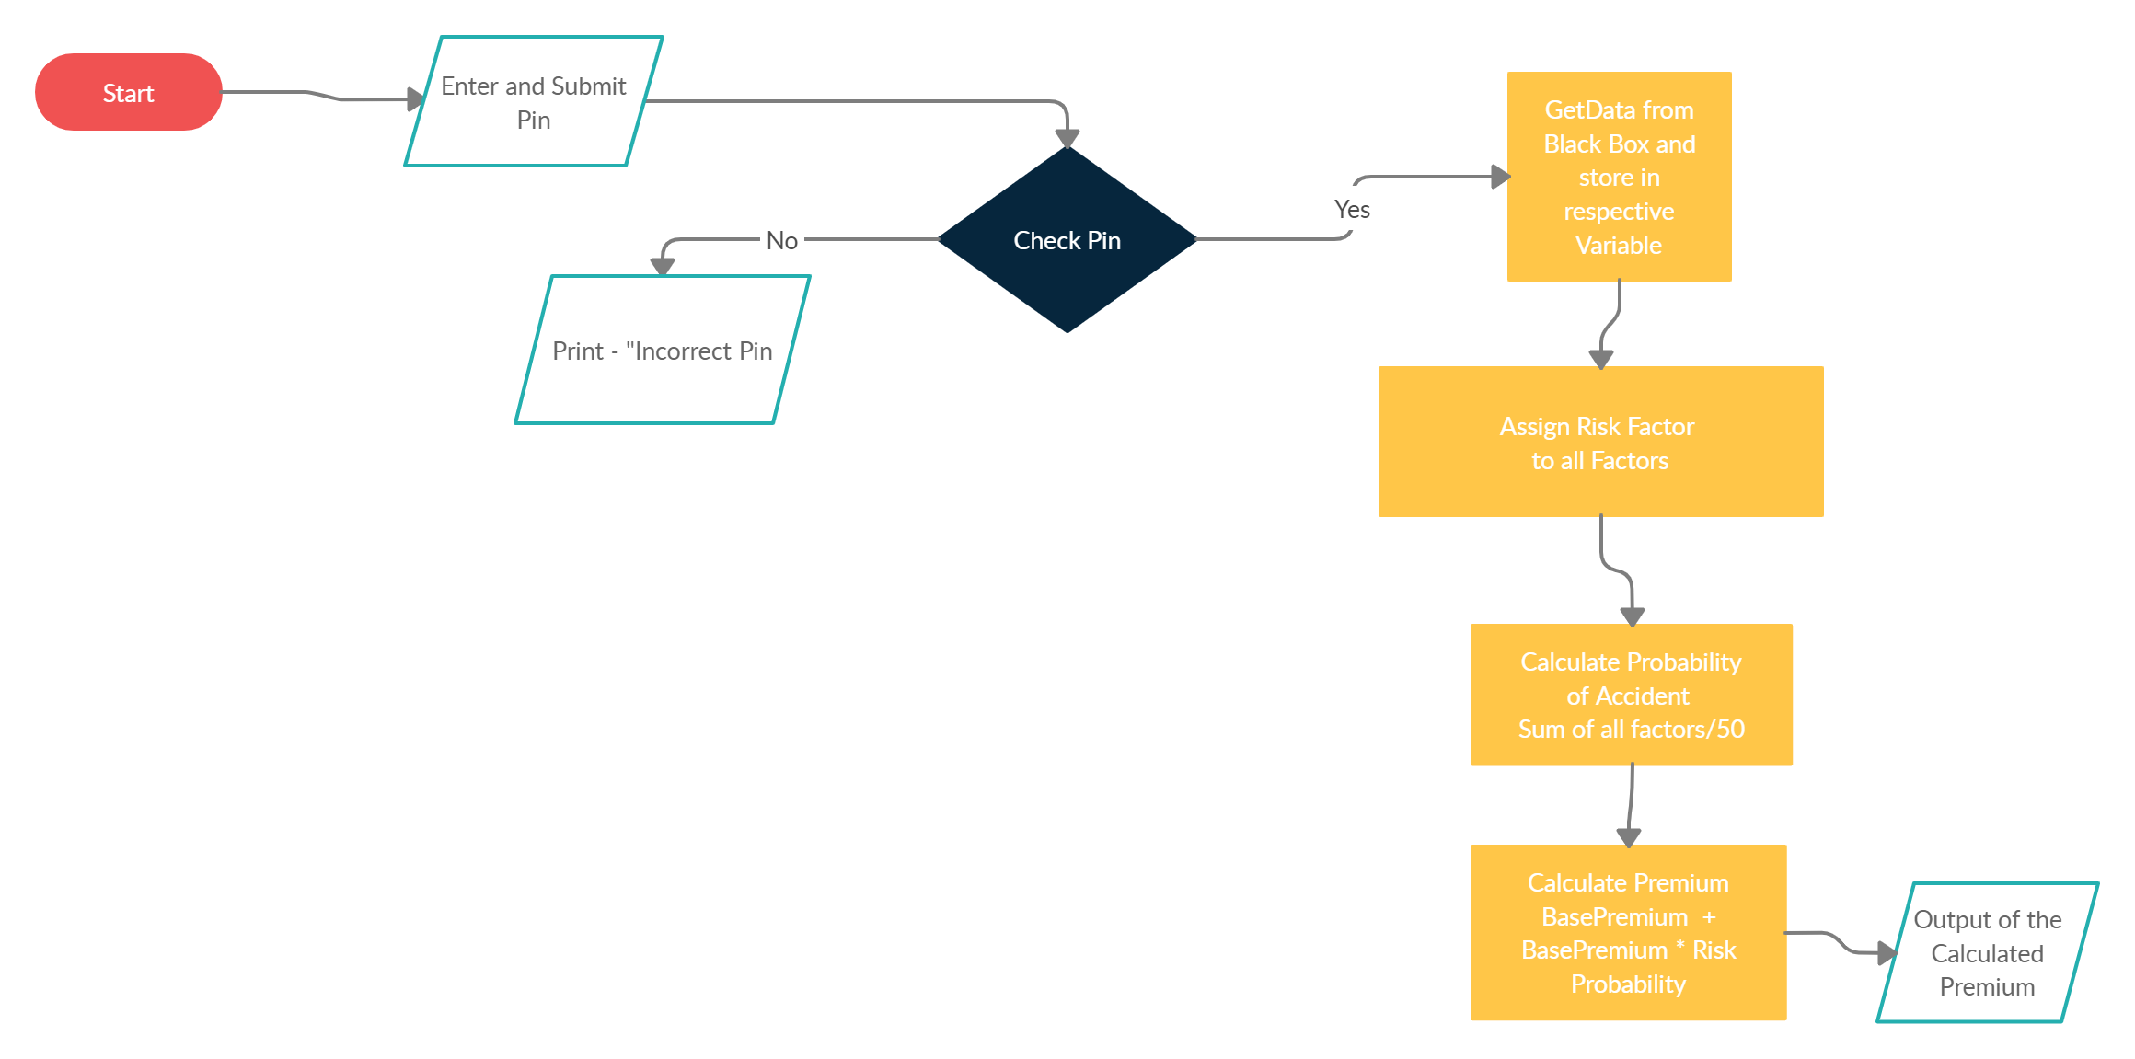

### Screen Layout

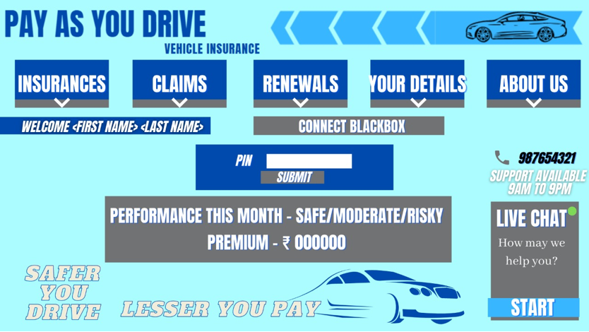

### Issues

None yet

# Backend Design:

## Index of Reference

This index gives details about where all a particular function has been referred.

|  |  |  |
| --- | --- | --- |
| finalPrem | unsigned float | Total Premium to be paid by the customer |

|  |  |  |
| --- | --- | --- |
| Function Name | Calling Screen / Report /procedure / function | Calling Screen / Report/ Procedure / Function |
| pinCheck() | Upload Data | Upload Data |
| getData() | Upload Data | Upload Data |
| assignRF() | Premium Calculation | Premium Calculation |
| getPrem() | Premium Calculation | Premium Calculation |
| premPrint() | Premium Calculation | Premium Calculation |

## PC001.lib

### pinCheck()

#### Brief Description / Functionality

Verifies user before starting data upload by looking up UID and PIN in the database.

#### Parameters

|  |  |  |  |
| --- | --- | --- | --- |
| Parameter Name | Description | Data Type | Input/output |
| UID | Unique Identification number issued to each customer | Unsigned long long integer | Input |
| PIN | 4-digit number to verify the user | Unsigned integer | Input |

#### Screens/Reports/Programs called

*None*

#### Business rules for data manipulation

UID cannot be changed by the user and can be altered by the client (insurance company) only with the permission of customer (end-user) and system admin.

PIN can be changed by customer (end-user) after verification with client (insurance company).

#### Tables Used with access mode

|  |  |  |  |  |
| --- | --- | --- | --- | --- |
| Table Name | Select | Insert | Update | Delete |
| Details | - | - | - | - |

#### Special Notes for the Developer

There can be only 3 attempts to enter PIN after which user has to verify himself with the company.

### getData()

* + - 1. *Brief Description / Functionality*

Verifies the Blackbox with UID and uploads Blackbox data to SFTP server after validation.

* + - 1. *Parameters*

|  |  |  |  |
| --- | --- | --- | --- |
| **Parameter Name** | **Description** | **Data Type** | **Input/output** |
| bbID | Fetched from Blackbox without user interference | Unsigned long long integer | Input |
| Blackbox Error | Error displayed when bbID cannot be matched with UID | String | Output |

* + - 1. *Screens/Reports/Programs called*

*None*

* + - 1. *Business rules for data manipulation*

bbID cannot be altered by anyone.

* + - 1. *Tables Used with access mode*

|  |  |  |  |  |
| --- | --- | --- | --- | --- |
| **Table Name** | **Select** | **Insert** | **Update** | **Delete** |
| Details | - | - | - | - |
| Blackbox |  |  |  | - |

* + - 1. *Special Notes for the Developer*

The upload log is to be updated on blackbox only after successful upload of data on server. If upload is interrupted, upload will not be considered.

### assignRF()

* + - 1. *Brief Description / Functionality*

Assigns Risk Factor values (RF values) to according to the received data based on certain conditions.

* + - 1. *Parameters*

|  |  |  |  |
| --- | --- | --- | --- |
| **Parameter Name** | **Description** | **Data Type** | **Input/output** |
| - | - | - | - |

* + - 1. *Screens/Reports/Programs called*

*None*

* + - 1. *Business rules for data manipulation*

The Risk Factor values are pre-determined and changing these values can lead to drastic change in premium. Thus, changes in the lookup RF values can be done only by consent of both insurance company and end-user and can be done by system administrator.

* + - 1. *Tables Used with access mode*

|  |  |  |  |  |
| --- | --- | --- | --- | --- |
| **Table Name** | **Select** | **Insert** | **Update** | **Delete** |
| Blackbox |  | - | - | - |
| BbDataRiskFactor |  |  |  | - |
| DetailsRiskFactor |  |  |  | - |

* + - 1. *Special Notes for the Developer*

*None*

### getPrem()

* + - 1. *Brief Description / Functionality*

Calculates Risk Probability using RF values and then calculate Final Premium of the end-user.

* + - 1. *Parameters*

|  |  |  |  |
| --- | --- | --- | --- |
| **Parameter Name** | **Description** | **Data Type** | **Input/output** |
| - | - | - | - |

* + - 1. *Screens/Reports/Programs called*

*None*

* + - 1. *Business rules for data manipulation*

bbID cannot be altered by anyone.

* + - 1. *Tables Used with access mode*

|  |  |  |  |  |
| --- | --- | --- | --- | --- |
| **Table Name** | **Select** | **Insert** | **Update** | **Delete** |
| Details | - | - | - | - |
| Blackbox |  |  |  | - |

* + - 1. *Special Notes for the Developer*

*None*

### premPrint()

* + - 1. *Brief Description / Functionality*

Print Final Premium and driving status.

* + - 1. *Parameters*

|  |  |  |  |
| --- | --- | --- | --- |
| **Parameter Name** | **Description** | **Data Type** | **Input/output** |
|  |  |  |  |

* + - 1. *Screens/Reports/Programs called*

*None*

* + - 1. *Business rules for data manipulation*

No data manipulation.

* + - 1. *Tables Used with access mode*

|  |  |  |  |  |
| --- | --- | --- | --- | --- |
| **Table Name** | **Select** | **Insert** | **Update** | **Delete** |
| Details |  | - | - | - |
| PremiumCalc |  | - | - | - |

* + - 1. *Special Notes for the Developer*

*None*